Editable Folk Dance Rehearsal Schedule

Folk Dance Club will meet on (date & time) in the music room beginning (date). To ensure that we learn the dances for the Festival, each student is only allowed one unexcused rehearsal to be able to participate in the Festival.

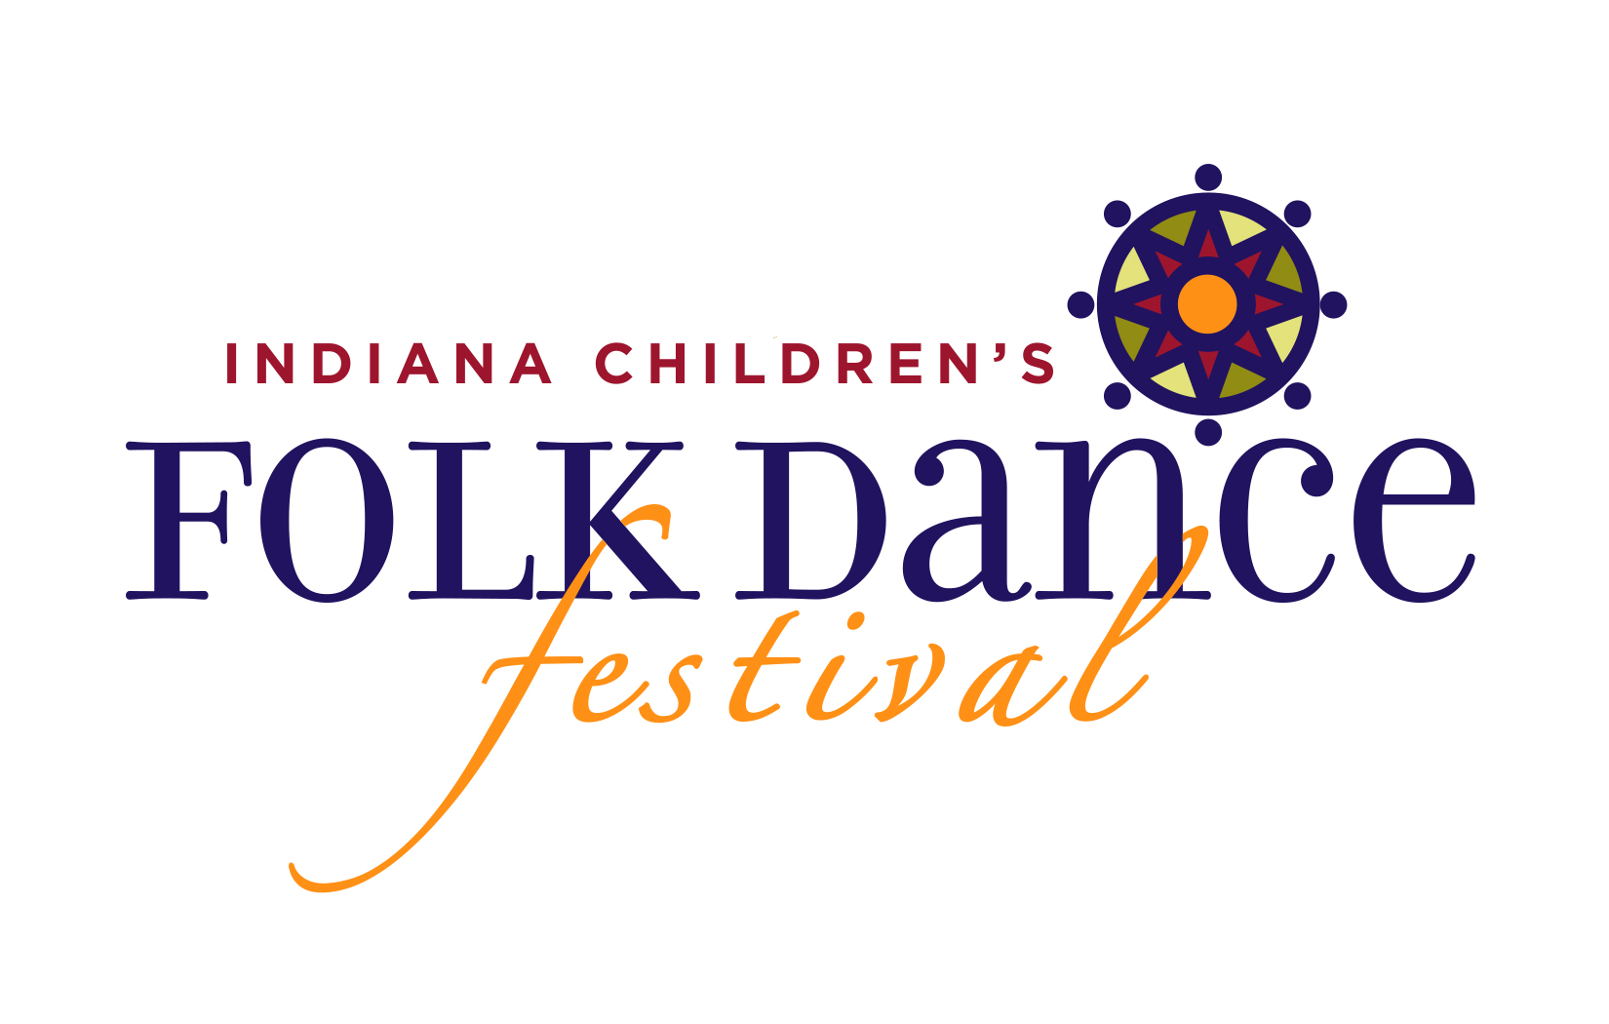
Folk Dance Club members will be participating with students from other schools in the IMEA Children’s Folk Dance Festival on (date) from 2:30 pm – 4:00 pm. Students attending rehearsals must also plan to attend the festival.

- date
- date
- date
- date
- date
- date
- Folk Dance Festival @ (location + date/time)

IMEA CHILDREN’S FOLK DANCE FESTIVAL:

- (date, location, time) (eat lunch before event)
- Arrive by 1:45pm at (location)
(address)
- Perform at 2:00pm
- Conclude at 4:00pm
- Parents take students home after event

