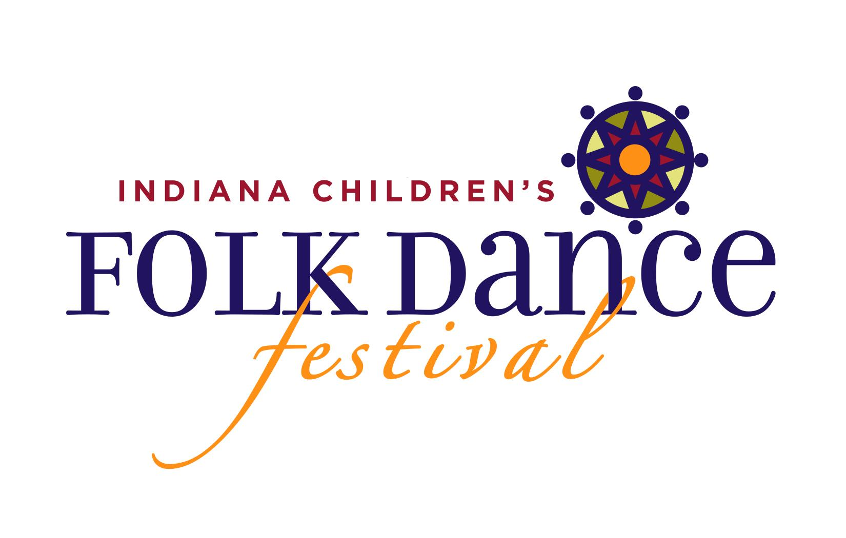
Dear Parent or Guardian:

On (date) from 2:00pm to 4:30pm, students will perform at the IMEA Children’s International Folk Dance Festival at (location).

Students and teachers from various schools and grade levels around Indiana will learn
international folk dances. At the festival, all of the children will perform these dances
together at the festival.

Included with this letter is:
- Dates of scheduled rehearsals
- A list of dances we will perform
- A one-page fact sheet with frequently asked questions (FAQ) about the festival.
- Parent Waivers & Policy statements (please sign and return)
- Ethnic Dance Ensemble Payment Form & Waiver (please sign and return)

We will go over each dance during the mandatory rehearsals, and students are
encouraged to practice at home. Should you have any questions about the dances or
festival, please contact [your music teacher].

Through the Children’s International Folk Dance Festival, we hope to generate a spirit
of togetherness, foster appreciation of other cultures, and encourage inquisitiveness
about the world around us. Music and dance allow us to share our cultures in a joyous
way.

I look forward to seeing you at the Festival!

Sincerely,

[Your Music Teacher]

Damon Clevenger
IMEA Children’s Folk Dance Festival Chair
damonclevenger@msdlt.k12.in.us

Marie Lawlor
Festival Director

